## M and E Thin Client

# Description

This is a mobile application that allows the user to post data (indicators) to a central server over an internet connection.

# Features

Below are the features of the M and E Thin mobile client:

* Post data over a HTTP connection

# Transport Technology

The HTTP protocol is used in transporting data to a central server

# UI Design

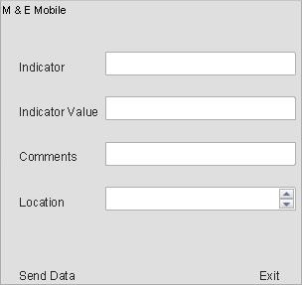

The user fills in data in the fields provided and clicks on the “Send Data” soft button, the application then takes the data provided, formats it for transport over a HTTP connection and posts the data to a specific web server.